
ASSISI –Italy

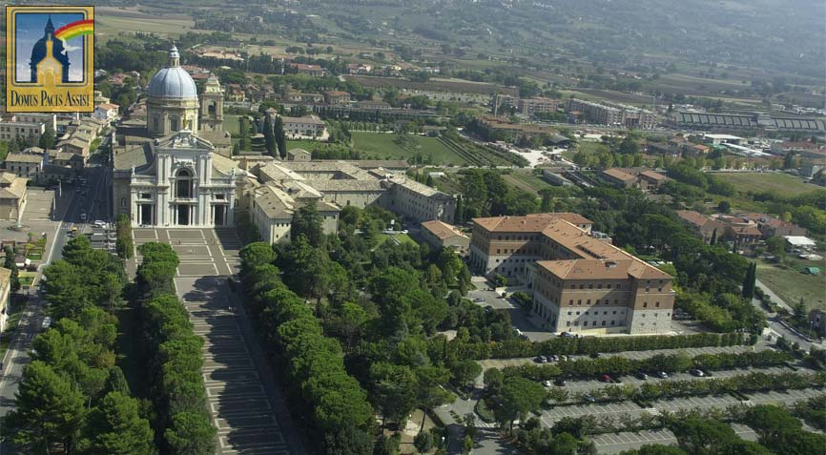
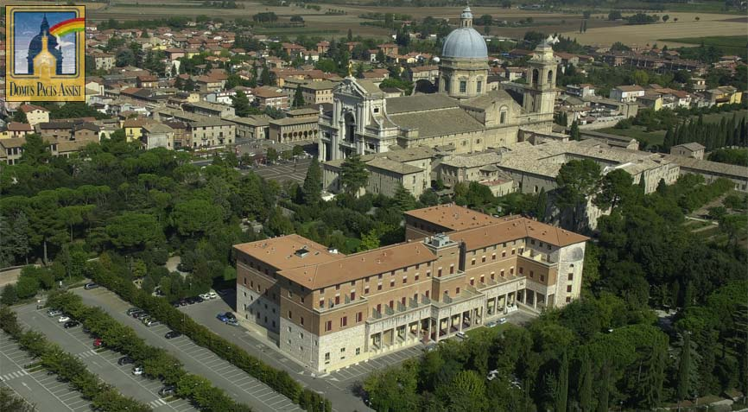
The Board of IEWG
The International Ecumenical Working Group for Pastoral Care among Deaf People

cordially invites IEWG members, pastors in Deaf Ministry,
Catechists, Diaconal workers and volunteers
involved in Ministry among Deaf people
to
The IEWG CONFERENCE 2010
In the Domus Pacis, Assisi
Santa Maria degli Angeli
19th-24th September 2010.

The theme of the conference is;

‘The Church among Deaf People – the next generation’.

We offer a special invitation to younger Deaf people (18 years+)
who are active in their church and, who could be the potential future leaders of the Church among Deaf People.
They will be representing the young Deaf Christians of their nation and will be given a full opportunity to tell us of their vision of the future of their Church.

As we learn and discuss, together and in workshops, what they have to tell us, we will also have high quality speakers to contribute to our
discussions.

Workshops will be on such subjects as sign language poetry, the use of visual aids and drama in church, and the use of the internet for pastoral care.

There will also be an opportunity for countries to share materials e.g. books, DVD’s etc.

Our conference is held in Santa Maria degli Angeli, near the beautiful town of Assisi and we will also have the opportunity to relax and see the town and its historical treasures.

We look forward to welcome you to the conference in September. If you would like to come, please fill in and send the Registration form which is with this letter.

Visit the Domu Pacis website:

http://www.domuspacis.it/

